minutes
Section 1: Meeting information
Meeting No: |  |  | 19 |  |  |  |  |  | Objective Ref:
Project / Meeting: |  |  | Port of Ashburton Community Consultation Committee
Location |  |  | Onslow Sports Club – 47 Third Avenue, Onslow
Date: |  |  | 4 Jun 2025 |  | Start time: |  | 15:00 |  | Time closed: |  |  | 16:30
section 2: participants’ details
Name |  |  |  |  | Organisation |  |  |  | Initials
Kylie Ronald |  |  |  |  | Community Member |  |  |  | KR
Cressida Mitchell |  |  |  |  | Community Member |  |  |  | CM
Felicity Brennan |  |  |  |  | Community Member |  |  |  | FB
Mike Chapman |  |  |  |  | Community Member |  |  |  | MC
Trevor Brown |  |  |  |  | Community Member |  |  |  | TB
Bree Maher |  |  |  |  | Community Member |  |  |  | BM
Mike Minogue |  |  |  |  | Pilbara Ports |  |  |  | CE
Melissa Wood |  |  |  |  | Pilbara Ports |  |  |  | MW
Paula Shepherd |  |  |  |  | Pilbara Ports |  |  |  | PS
Ariana St-Pierre |  |  |  |  | Pilbara Ports |  |  |  | AS
SECTION 3: AGENDA
Item |  | Agenda Topic |  |  |  |  |  |  |  | Action Items
 |  |  |  |  |  |  |  |  |  | Whom
 |  | Welcome And Apologies |  |  |  |  |  |  |  | PS
 |  | terminal Operations Update |  |  |  |  |  |  |  | PS
 |  | Marine Operations Update |  |  |  |  |  |  |  | MM
 |  | Environment and Heritage Update |  |  |  |  |  |  |  | MW
 |  | Community Update |  |  |  |  |  |  |  | AS
 |  | Discussion and Question / Other Business |  |  |  |  |  |  |  | ALL
section 4: next meeting
Date: |  |  |  | Time Open: |  |  |  | Time Close:

Minutes of meeting held at the Onslow Sports Club,
3 June 2025

ITEM 1 WELCOME AND INTRODUCTION OF MEMBERS

Chair welcomed all present and declared the meeting open at 15:00. The chair commenced the meeting with an introduction of all members in attendance.

ITEM 1.1 ACTION ITEMS
Nil.

ITEM 2 TERMINAL OPERATIONS UPDATE
Port Manager Ashburton Paula Shepherd
Key Focus Areas for FY25

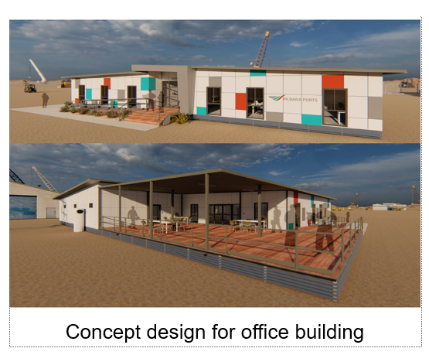
Safety: Continuously improve safety protocols across the Port
Community engagement: Strengthen ties with the local Onslow community through proactive engagement
Foundation projects: Office building, power, water, biosecurity, lighting, bollards, firefighting equipment
Office building: to be completed by April 2026
Desalination plant: to provide water to the Port and customers
Power project: solar, battery solutions removing reliance on diesel generators
Biosecurity area upgrade: Significant investment underway in biosecurity infrastructure to support First Point of Entry (FPOE) status

First Point of Entry
Federal Government’s support of First Point of Entry (FPOE) status for Ashburton marks a major milestone. This will not only streamline the import of essential decarbonisation equipment but also cut emissions, enhance supply chain efficiency, and open exciting opportunities for direct freight services. While some final steps remain before Ashburton can function fully as an FPOE port, this progress underscores the critical role regional ports play in building a sustainable and resilient future.

Update – transfer of the Port of Onslow
The transfer from the Department of Transport to Pilbara Ports will ensure the Port of Onslow is managed by a local Pilbara team, with a permanent presence in Onslow.
While the date for transfer is yet to be determined, Pilbara Ports is working collaboratively to ensure it occurs as efficiently as possible.
Pilbara Ports invite discussions with stakeholders and community members throughout the transfer process.
Highlights
- New hybrid lighting towers
- Preparation of McConnell Dowell barge arrival 750t crane
Questions:
There was a question about if the FPOE status had already been accepted for Ashburton. Pilbara Ports advised that the Federal Government is still investigating the requirements for the status to be official.

There was a question on timeframe for the FPOE status to be official. Pilbara Ports advised that they are expecting it before the end of the year.

There was a question about what is required for the FPOE status to be officialised. Pilbara Ports advised that the Federal Government is conducting a needs analysis and will report back to Pilbara Ports with a list of needs.

There was a question about if the hybrid lighting towers are turtle friendly. Pilbara Ports advised that they are.

There was a question about if with the FPOE status, the Federal Agencies will have a presence in town. Pilbara Ports advised that the ABF and Biosecurity are investigating this.
ITEM 3 MARINE OPERATIONS UPDATE
Harbour Master Marine West Mike Minogue
Vessel arrivals & Movements
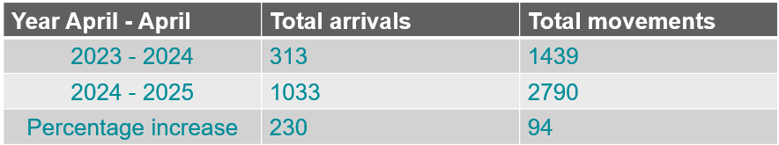
Updates
- Pilbara Ports has had its own pilots engaged in Ashburton for a year
- Training up Min Res transhippers crews – 4 TS
- The Port is seeing more traffic offshore and supporting project works for Mardie
- The delivery of the fifth and final MinRes ATB, MinRes Peak + MinRes Vidar in the port.
- A Deputy Harbour Master is at the Port of Ashburton most weeks.
- The last week of May saw the successful completion of the survey of the Wheatstone submarine trunkline subsea gas pipeline.

Pilotage and VTS coverage
- Onslow Port take over - Pilbara Ports is ready to take over running of the port once the transfer has taken place.
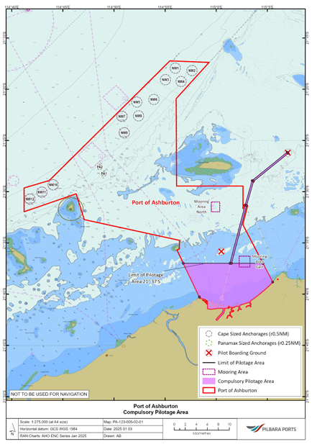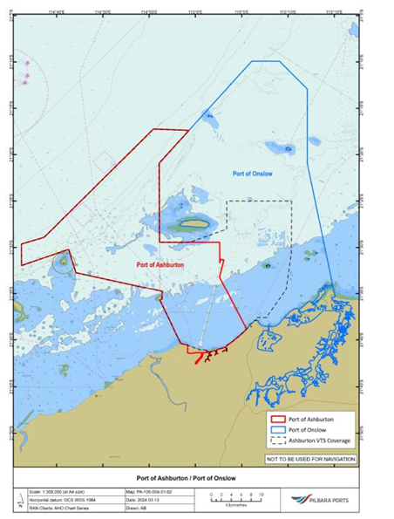
Contact details
Ashburton VTS Contacts
Landline – (08) 91596556 (available 24/7/365)
Mobile – 0428 888 800
Email: dampier.vts@pilbaraports.com.au
VHF Channels 14 and 16
Harbour Masters office
HM.DHM@pilbaraports.com.au
Duty HM 24/7
+61 407 405 797
There was a question about if with the Port of Onslow transfer will Pilbara Ports change the recreational status of the port. Pilbara Ports advised that there were no plans to change the recreational status.

There was a question about how Pilbara Ports will manage the recreational vessels in the Port of Onslow. Pilbara Ports advised that the recreational vessels will be managed the same way as with other ports, through the Vessel Traffic Services.

There was a question about how Pilbara Ports will mitigate the risks of accidents with recreational vessels at the Port of Onslow and Beadon Creek. Pilbara Ports advised that the Recreational Vessel Safety Campaign is conducted yearly to promote awareness and education. The charts are continuously updated, and Pilbara Ports works with Department of Transport through the Decky application to keep recreational boaters updated.

There was a question about if Pilbara Ports will eventually have an office in town. Pilbara Ports advised that the plan is to utilise the Department of Transport offices at Beadon Creek as a town office. In the meantime, Pilbara Ports will utilise space at the Onslow Chamber of Commerce and Industry.

ITEM 4 ENVIRONMENT AND HERITAGE UPDATE
Environment and Heritage Advisor Melissa Wood
- Biannual Coastal Processes Survey completed in May
- Another supplementary post bypassing survey completed early-February
- Sand Extraction Zone (SEZ) currently at 187,300m³ (under trigger of 200,000m³)
- Changes to East Ashburton Chenier – push through to west and eastern opening adjacent to ACW
- Sand bypassing was completed mid-September 2024

Marine Environmental Quality Monitoring program
- Phase 1, or ‘baseline monitoring’, within our marine monitoring program.
- Marine water and sediment quality results - relevant environmental quality objectives were achieved.
- We continue to expand our program to measure, monitor and protect the marine environment at all our Ports to ensure our activities align with the best environmental practice.

General update
- SWASP Samples sent for Summer Soak February 2025
- SWASP Winter 2024 report
    - Didemnum perlucidum
- Box Jellyfish have been seen in the Port of Ashburton
- Felixer- cat trapping hoping to continue
There was a question about if Pilbara Ports would be happy to share the results of the Marine Environmental Quality Monitoring program. Pilbara Ports advised they would be happy to share the results.

ITEM 5 COMMUNITY UPDATE
Community Relations Lead Ariana St-Pierre

Small grants
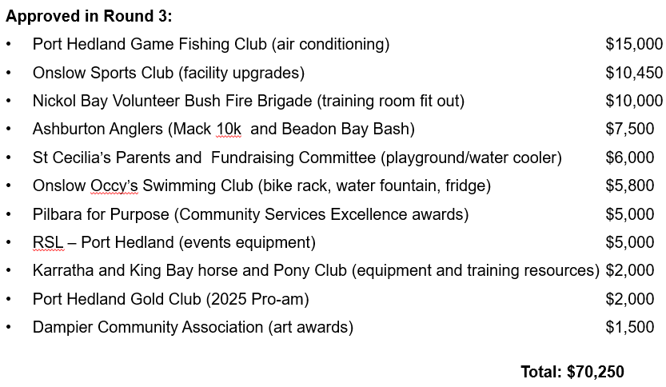
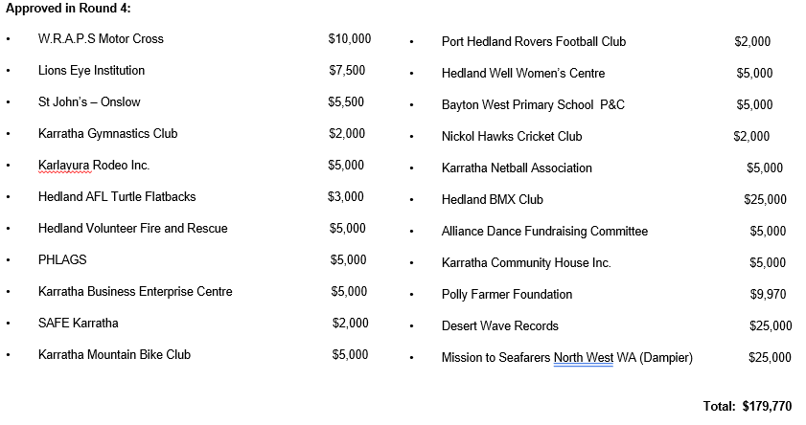
Small grants geo-distribution round 1-2-3-4
Funding prioritised towards:
- Legacy impact, such as the purchase of infrastructure or equipment
- Support of First Nations community
- Social inclusion
- Mental health resilience

Reasons applications were not supported:
- Travel to Perth
- Consumables (no legacy impact, maximum $2,000)
- Retrospective applications

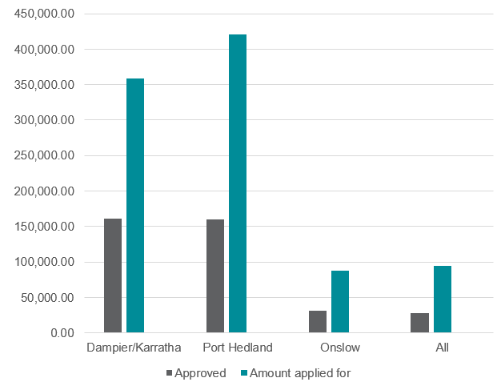
Sponsorships

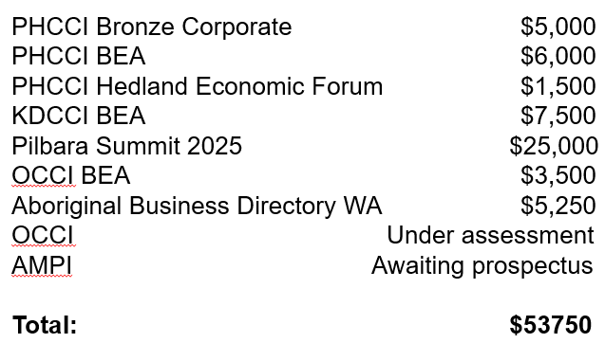

Partnerships
Marine Rescue Port Hedland (MRPH)
- Replacement of a 100-year-old dilapidated building.
- Pilbara Ports paid 2nd and final instalment of $100,000 to bring a total commitment to $200,000.
Murujuga Aboriginal Corporation (MAC) - construction of the new ranger training facility shed
Formal acknowledgement of ongoing collaborations:
- Accumulation of sea time for rangers whilst completing mooring inspections
- Mangrove rehabilitation and seed supply
Builds on existing commitments from MAC and funding from:
- 2-year commitment from Pilbara Ports
- $200,000 over two annual instalments
- Acquittal of 1st instalment required before payment of 2nd
Local Government Authorities
Shire of Ashburton 2-year agreement ($240,000)
- Activation of space through placemaking projects
- Markets, arts events, community gardens, beautification

City of Karratha 1-year agreement ($100,000)
- Awards sponsorships (Arts, Sports, Youth)
- City Footpath Solar Lighting program

Town of Port Hedland 1-year agreement ($75,000)
- Youth adventure park infrastructure
- Ship to Shore and Good Night's concert series events
- Seniors and Youth programs
- Awards sponsorship (Citizen and Sports

Tours
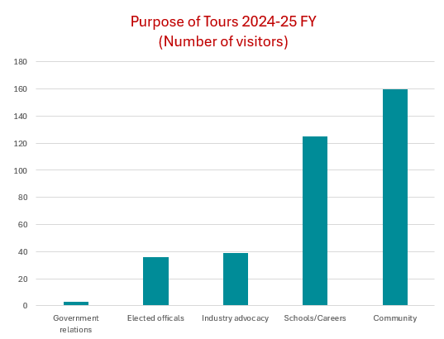

There was a question about if Pilbara Ports would be interested in participating in a Grants Roadshow with industry groups. Pilbara Ports advised that they would be happy to participate.

There was a question about if there is an intention to be a Seafarers Centre in Ashburton. Pilbara Ports advised that at this stage there isn’t, but they will do whatever they can to support the seafarers in the meantime.

ITEM 6 DISCUSSION & QUESTIONS
Chair opened discussion for members and attendees to raise any questions or make comments.
There was a question about if Pilbara Ports is planning on building houses for their growing team. Pilbara Ports advised that it’s in the plans.

Chair thanked all those in attendance and closed the meeting at 17:00.
Close

