minutes
Section 1: Meeting information
Meeting No: |  |  | 29 |  |  |  |  |  | Objective Ref:
Project / Meeting: |  |  | Port of Dampier Community Consultation Committee (DCCC)
Location |  |  | Pilbara Ports Karratha Office Board Room
Date: |  |  | 04/06/2025 |  | Start time: |  | 15:00 |  | Time closed: |  |  | 17:00
section 2: participant’s details
Name |  |  |  |  | Organisation |  |  |  | Initials
Ariana St-Pierre |  |  |  |  | Pilbara Ports |  |  |  | AS
Mike Minogue (Chair) |  |  |  |  | Pilbara Ports |  |  |  | MM
Georgie Arthur |  |  |  |  | Pilbara Ports |  |  |  | GA
Matthew Lee |  |  |  |  | Pilbara Ports |  |  |  | ML
Bill Bardsley |  |  |  |  | Pilbara Ports |  |  |  | BB
Luke Whitlam |  |  |  |  | Pilbara Ports |  |  |  | LW
Mohanna Donnelly |  |  |  |  | Pilbara Ports |  |  |  | MD
Heather O’Keefe |  |  |  |  | Community Member |  |  |  | HO
Kodie Bickler |  |  |  |  | Community Member |  |  |  | K
Gill Furlong |  |  |  |  | Community Member |  |  |  | GF
Bev Menzel |  |  |  |  | Community Member |  |  |  | BM
Brendon Johansen |  |  |  |  | Community Member |  |  |  | BJ
Tony Simpson |  |  |  |  | Community Member |  |  |  | TS
SECTION 3: AGENDA
Item |  | Agenda Topic |  |  |  |  |  |  |  | Action Items
 |  |  |  |  |  |  |  |  |  | Whom
 |  | Welcome / Introductions |  |  |  |  |  |  |  | MM
1.1 |  | RECORD of attendance/Apologies  Minutes of last meeting |  |  |  |  |  |  |  | MM
2. |  | Marine OPERATIONS Update |  |  |  |  |  |  |  | MM
3. |  | ENVIRONMENT AND HERITAGE UPDATE |  |  |  |  |  |  |  | BB
4. |  | TERMINAL OPERATIONS UPDATE |  |  |  |  |  |  |  | GA
5. |  | Community Update |  |  |  |  |  |  |  | AS
6. |  | PROJECTS UPDATE: Dampier Cargo Wharf |  |  |  |  |  |  |  | ML
7. |  | any other business |  |  |  |  |  |  |  | ALL
8. |  | Visit to the vessel traffic services centre
section 4: next meeting
Date: |  |  |  | Time Open: |  |  |  | Time Close:

Minutes of the meeting held at the Pilbara Ports Karratha Office Board Room
04 June 2025

ITEM 1 WELCOME AND INTRODUCTION OF MEMBERS

The Chair welcomed all present and declared the meeting open at 16:15. The chair then commenced the meeting with an introduction of all members in attendance.

Apologies

Community Member Eloise Dortch (ED)
Community Member Sarah Wheelan (SW)

ITEM 2 MARINE UPDATE
Harbour Master Marine West Mike Minogue
Cargo Statistics
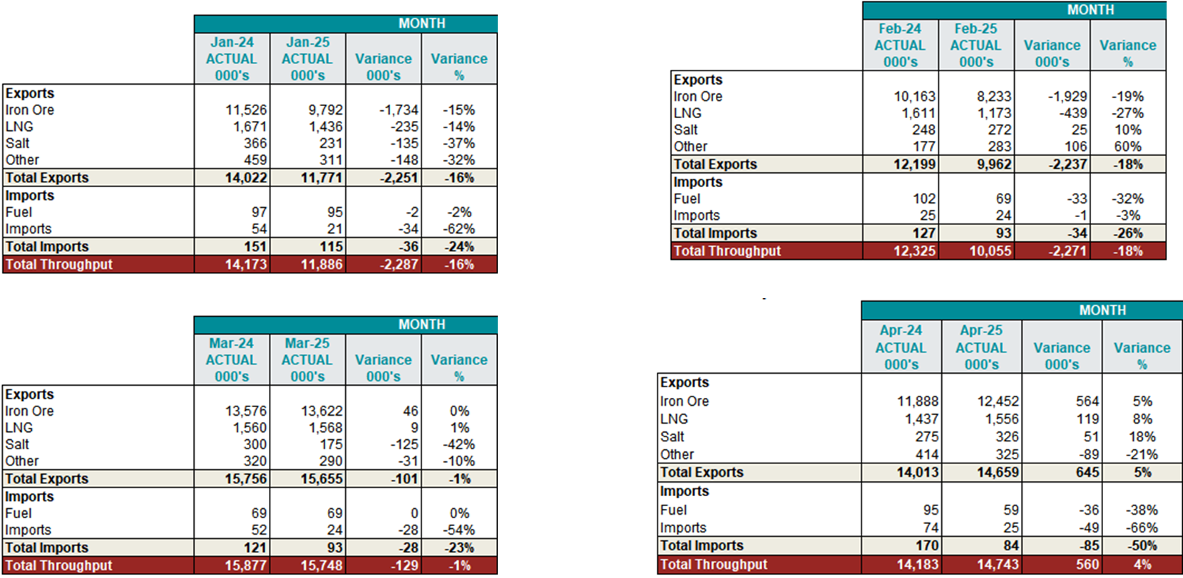
Perdaman Project Destiny
The month of February saw commencement of the first Perdaman Project modules by Heavy Lift Rolldock S-Class vessels. Three shipments to date.
Moor to sea for MAC’s rangers
In April, four Murujuga Aboriginal Corporation (MAC) Rangers, along with Pilbara Ports First Nations Engagement and Marine team, came together for a monthly Marine Mooring check. These tours are significant in strengthening the ongoing partnership between MAC and Pilbara Ports. As part of this agreement, we support MAC Rangers in gaining valuable sea hours, one of the requirements for obtaining their coxswain ticket.
Successful firefighting and wreck removal
A successful operation involving Marine and Environment teams, and different port stakeholders, resulted in prompt fire extinguishing and subsequent wreck removal from the port waters. Environment team conducted successful shoreline clean-up.
Marine work experience trainee
Pilbara Ports works closely with the STARS FOUNDATION. Under this initiative Pilbara Ports created a paid marine work experience position commencing in June 2025 for Alira. Alira is a young First Nations woman who had expressed an interest in a marine career.
Question:
There was a question as to whether anyone got hurt during the fire on the vessel. Pilbara Ports advised that there were no injuries as there was no one on the anchored vessel.
ITEM 3 ENVIRONMENT UPDATE
Environment and Heritage Advisor Bill Bardley
Environmental aspects of DCWELR project
- Weekly environmental inspections
- Bubble curtain
- Silt curtain
- Management of spills
- Heritage inspections
Coral colonisation - dredging
Large rocks were removed and taken to East Lewis Island Spoil ground. The floor was raised to facilitate placement of (granophyre) rocks, with the aim for colonisation of coral species. Pilbara Ports has surveyed with drop cameras prior to placement to determine that the target area was not previously colonised by corals. There should be a net increase in future fishing grounds.

ITEM 4 TERMINAL OPERATIONS
Port Manager Dampier Georgie Arthur
Shipping and Cargo Information
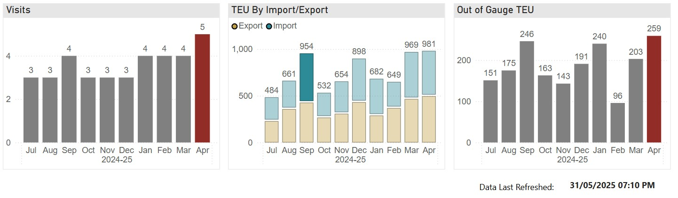

Container volumes have been consistent but are expected to rise as projects in the region begin to accelerate. The graphic depicts container trade up to including April 2025. Final figures for May are still pending.

In May 2025 the Dampier Public berths hosted:
- 3 General Cargo Vessels
- 8 Offshore Supply Vessels
- 5 Bulk Liquid Import/Exports
- 4 Container Vessels

Cruise Vessels – Dampier
The Port of Dampier is expecting 2 Cruise vessel visits in August 2025. Embarking in Broome travelling down the West Australian coast to Fremantle and returning at the end of the month:
- Le Soleal – A small luxury cruise ship at 142m, caters for up to 264 guests and 145 crew members.
- The Seatrade Cruise Global (the biggest cruise trade event in the world) was hosted in Miami in April.

WA Tourism as well as other Australian ports attended the Australian Cruise Association stand - growing interest in Dampier from expedition cruise lines. Pilbara Ports will continue to work collaboratively with Tourism WA and Australian Cruise Association to explore these opportunities and bring tourism to Dampier and surrounding business.

Question:
There was a question as to why the container ships pass through Singapore. Pilbara Ports advised that the ships are travelling in a loop that includes Singapore.

ITEM 5 COMMUNITY
Community Relations Lead Ariana St-Pierre
Small Grants Program
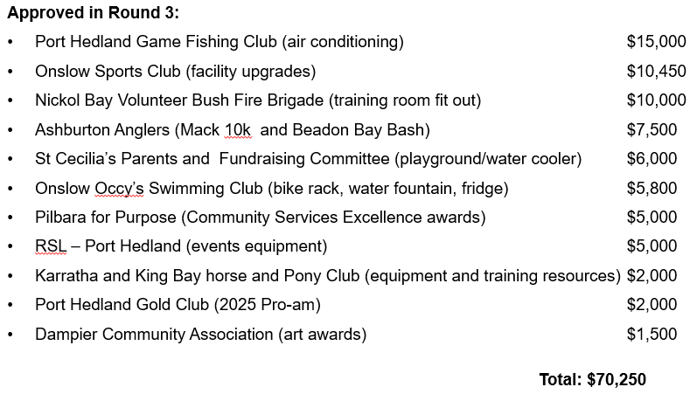
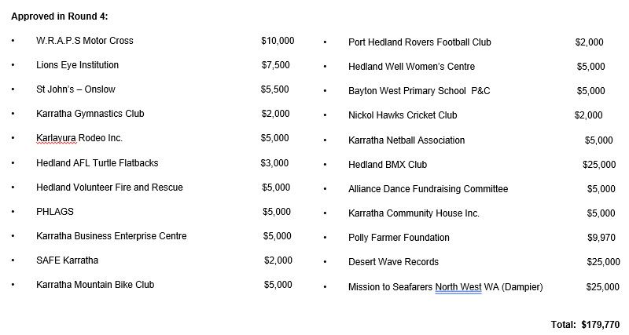
Small Grants Geo-Distribution Round 1-2-3-4 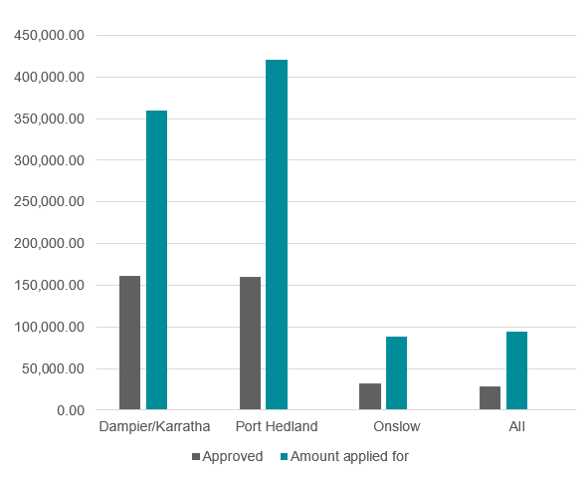
Funding prioritised towards:
- Legacy impact, such as the purchase of infrastructure or equipment
- Support of First Nations community
- Social inclusion
- Mental health resilience

Reasons applications were not supported
- Travel to Perth
- Consumables (no legacy impact, maximum $2000)
- Retrospective applications

Sponsorships
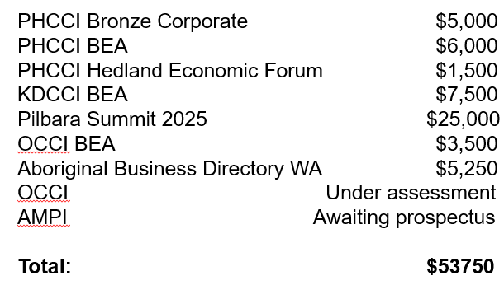
Partnerships
- Marine Rescue Port Hedland (MRPH)
  - Replacement of a 100-year-old dilapidated building.
  - Pilbara Ports paid 2nd and final instalment of $100,000 to bring a total commitment to $200,000.
  - Total funding secured by MRPH $2,836,000
  - New office construction (under tender)
- Murujuga Aboriginal Corporation (MAC)
  - Construction of the new ranger training facility shed.
  - Formal acknowledgement of ongoing collaborations:
  - Accumulation of sea time for rangers whilst completing mooring inspections
  - Mangrove rehabilitation and seed supply
  - $200,000 over two annual instalments
  - Acquittal of 1st instalment required before payment of 2nd
- Local Government Authorities
  - Shire of Ashburton 2-year agreement ($240,000)
    - Activation of space through placemaking projects
    - Markets, arts events, community gardens, beautification
  - City of Karratha 1-year agreement ($100,000)
    - Awards sponsorships (Arts, Sports, Youth)
    - City Footpath Solar Lighting program
  - Town of Port Hedland 1-year agreement ($75,000)
    - Youth adventure park infrastructure
    - Ship to Shore and Good Night's concert series events
    - Seniors and Youth programs
    - Awards sponsorship (Citizen and Sports)

Tours
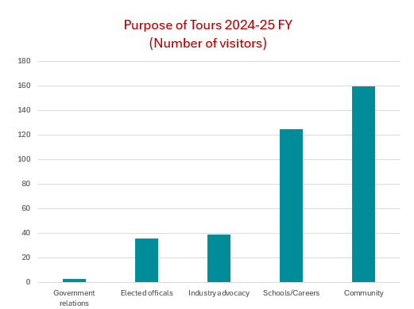
Question:
There was a question asked about if Pilbara Ports can facilitate tours in Dampier. Pilbara Ports advised that this is subject to staff availability, currently both members of the Community Relations team are based in Hedland.

There was a question asked about plans to grow the Community Relations team. Pilbara Ports advised that there are potential plans to grow the team in the longer term, subject to budget considerations and port growth/demand.

ITEM 6 DAMPIER CARGO WHARF EXTENSION AND LAND RECLAMATION PROJECT (DCWELR)
Senior Project Manager – Civil (DCWP) Matthew Lee

Dampier Bulk Handling Facility overview
Stage 1 of the Dampier Cargo Wharf Projects, encouraging trade diversification by opening access to a world-wide urea market. The project team is focused on maintaining port operations while delivering the various components of the new DBHF.
Update:
- Demolition of the existing heavy load out (HLO) and alternate load-out facility (ALF) was completed in March.
- The installation of culvert units under Mof Road, to facilitate Perdaman’s conveyor system, was also completed in March.
- Drilling and blasting were completed on 30 April and dredging on 12 May. This has created a new berth pocket and vessel manoeuvring area.

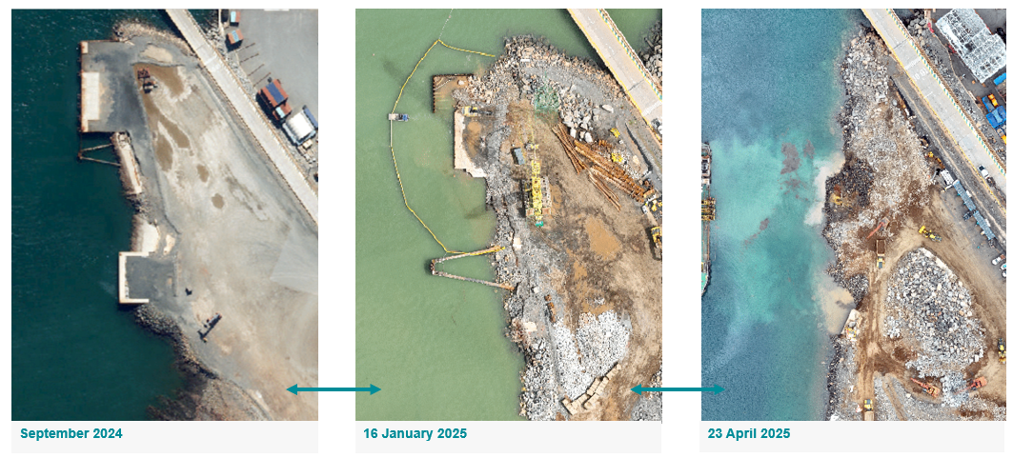
Next steps:
- Piling via a rotary piling rig will commence this week.
- The rig will drill a socket while the piles drive into the seabed.
- 120 steel piles will be installed to support the new 200 metre concrete wharf.
Stages 2 and 3 of the Dampier Cargo Wharf Projects
- The Dampier Link Bridge (DLB) and Dampier Cargo Wharf (DCW) refurbishment are Stages 2 and 3 of the Dampier Cargo Wharf Projects.
- The design and construct tender for the DLB closes 16 June 2025, with construction expected to start by mid-2026.
- The Early Contractor Involvement (ECI) tender for the DCW closes 16 June 2025. The ECI process will allow Pilbara Ports to develop an innovative and cost-efficient approach to refurbishment, with a design and/or construct tender to be released once scope is defined.
Question:
There was a question as to whether the piling will be utilising the bubble curtain process. Pilbara Ports advised that it was the case.

ITEM 9 ANY OTHER BUSINESS
Nil

Chair thanked all those in attendance and closed the meeting at 17:00
Close

