- SECTION 1: Meeting Information
Meeting No: 28
Meeting: | Port of Port Hedland Community Consultation Committee (PHCCC)
Location: | Pilbara Ports, L5 Kariyarra Room
Date: | 27 May 2025 |  |  | Time Open: | 16:50 |  | Time Close: | 18:00
- SECTION 2: Participants Details
Name |  | Organisation |  |  |  | Initials
Philip Christy (Chair) |  | Pilbara Ports |  |  |  | PC
Ariana St-Pierre |  | Pilbara Ports |  |  |  | ASP
Russell Trowbridge |  | Pilbara Ports |  |  |  | RT
Nava Gowtheepan |  | Pilbara Ports |  |  |  | NG
Shelby Noble |  | Pilbara Ports |  |  |  | SN
John Freimanis |  | Pilbara Ports |  |  |  | JF
Chris Vale |  | Pilbara Ports |  |  |  | CV
Karen Gray |  | Pilbara Ports |  |  |  | KG
Veronica Keelan |  | Pilbara Ports |  |  |  | VK
Joel Schreiber |  | Community Member |  |  |  | JS
Scott Love |  | Community Member |  |  |  | SL
Scott Ballem |  | Port Hedland Chamber of Commerce and Industry |  |  |  | SB
Byron Everett Klein |  | Community Member |  |  |  | BE
Roger Higgins |  | Community Member |  |  |  | RH
Lorrain Butson |  | Town of Port Hedland Councillor |  |  |  | LB
Ambika Rebello |  | Town of Port Hedland Councillor |  |  |  | AR
Gary Silcock |  | Community Member |  |  |  | GS
Arnold Austin Carter |  | Community Member |  |  |  | AC
Kelly Howlett |  | Community Member |  |  |  | KH
Gloria Jacob |  | Community Member |  |  |  | GJ

Minutes of the meeting held at the Hedland Tower
Tuesday, 27 May 2025

ITEM 1 WELCOME AND INTRODUCTION OF MEMBER

The chair welcomed all present and declared the meeting open at 16:15. The acting chair then commenced the meeting with an introduction of all members in attendance.

ITEM 1.1 RECORD OF APOLOGIES

Apologies
Town of Port Hedland Councillor Ambika Rebello (AR) Town of Port Hedland Councillor Lorraine Butson (LB)
Senior Environment Advisor Zoe Keller (ZK)
Port Manager Port Hedland East Veronica Keelan (VK)
Community Member Arnold Carter (AC)
Community Member Kelly Howlett (KH)
Community Member Gary Silcock (CS)
Community Member Gloria Jacob (GJ)

ITEM 1: ACTIONS FOR COMMUNITY CONSULTATION COMMITTEE
Please encourage community members who may be interested in joining the Community consultation Committee to submit an expression of interest.

Decide the winning entry of the Name the Lumsden Point Cranes competition in the next financial year.

ITEM 2: MARINE OPERATIONS UPDATE
Harbour Master Port Hedland Nava Gowtheepan
Port Statistics:
- January 2025: 46.525 million tonnes, an increase of 8% from 2024.
- February 2025: 37.470 million tonnes, a decrease of 5% from 2024.
- March 2025: 51.537 million tonnes, an increase of 2% from 2024
- April 2025: 47.476 million tonnes, a decrease of 5% from 2024

Marine incidents at Port Hedland: 1 January 2025 – 30 April 2025
Total marine events: 40
While these have been classified as incidents, these are marine events which have each been successfully handled in line with our emergency response procedures and marine team.
Port Operations
- 2 vessel emergencies (towage & mooring line failures).
- Ongoing replacement of mooring infrastructure.

Pilotage Operations
- Pilbara Ports has an in-house marine pilotage team with support structure of Marine Services Superintendent and Marine Services Manager.
- Pilbara Ports has also engaged Auriga Pilots to assist with maintaining adequate supply of marine pilots to service the needs of Port Hedland for now and into the future.
- Pilbara Ports Marine Pilotage team has completed several training exercises in and out of Port Hedland
- Pilot Team works closely with internal operations team and Port Hedland Terminal operators under the leadership of the Harbour Master Team.
- Marine Pilot Team utilises Pilbara Ports Marine Simulation Centre for current and ongoing training.
Questions
There was a question as to if the Pilot Training simulator facility is permanent. Pilbara Ports advised that the current simulator is not our first choice of location but is serving its purpose. There is a long-term plan to locate it in a different building.
There was a question as to if there is a theoretical limit to the throughput quantity? Pilbara Ports advised that the channel width poses the biggest limitation on shipping from Port Hedland.
ITEM 4 TERMINAL OPERATIONS UPDATE
Executive General Manager Terminal Operations Nick Perceval
Utah Throughput: February to April 2025
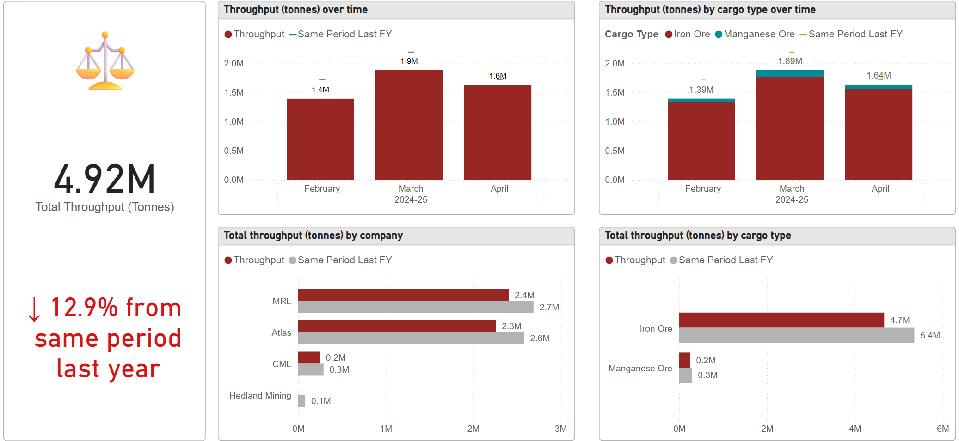
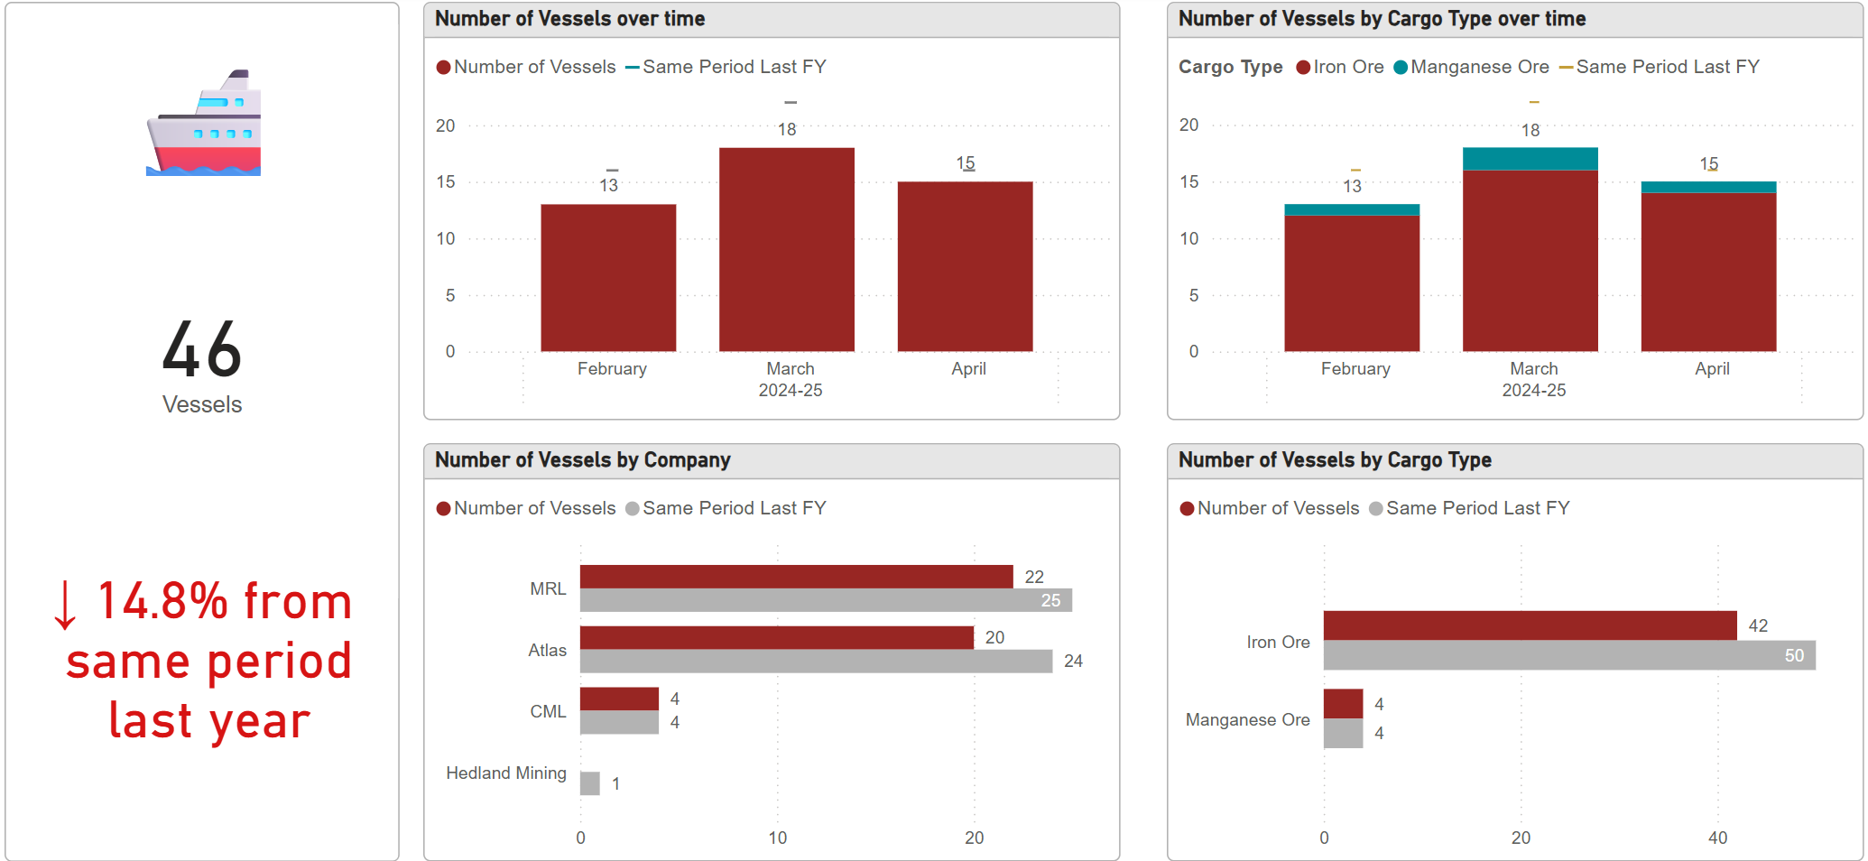

Eastern Harbour Statistics: Feb – April 2025
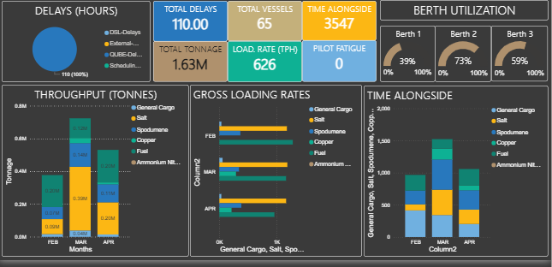

Questions
There was a question as to how much Ammonia Nitrate gets shipped out of Port Hedland? Pilbara Ports advised that there was only one shipment from Port Hedland this financial year. It mostly gets exported from Dampier cargo wharf.

ITEM 5 ENVIRONMENT AND HERITAGE UPDATE
Environment Advisor (Port Hedland) Shelby Noble

Vertebrate Pest Management Program
Monitoring undertaken in April. Initial results:
- Captures for the event included 7 cats, and no foxes
- Cat evidence was reduced compared to previous events
- Fox evidence was significantly reduced compared to previous events, with very few signs of transient fox activity
- Bait uptake was difficult to assess, with Cyclone Zelia washing out most of the bait stations
- No evidence of predation
- Awaiting the final report.

Osprey Nesting Season
Osprey breeding season runs from April to July in the Pilbara. Ideal nesting locations are on a tall platform, close to the water and with a 360º view. Once a nest has eggs or fledglings in it, it is protected under the Biodiversity Conservation Act 2016. Pilbara Ports has several nesting platforms within the inner harbour to encourage nesting on these, away from port operational infrastructure
Questions:
There was a question as to what extent is the environmental scrutiny on the operations of the Port and projects. Pilbara Ports advised that it is subject to the same environmental regulations as other locations. Pilbara Ports has confidence that every action taken has the least environmental impact possible.

There was a question as to if there is a risk of a bull shark attack in the new marina. Pilbara Ports advised that there are risks of shark attacks in coastal ecosystems. The marina falls under department of transports jurisdiction, if you see or hear about sharks, please advise them.

ITEM 6 COMMUNITY UPDATE
Community Relations Lead Ariana St-Pierre
Community Grants Approved in Round 3:
Port Hedland Game Fishing Club (air conditioning) $15,000
Onslow Sports Club (facility upgrades) $10,450
Nickol Bay Volunteer Bush Fire Brigade (training room fit out) $10,000
Ashburton Anglers (Mack 10k and Beadon Bay Bash) $7,500
St Cecilia’s Parents and Fundraising Committee (playground/water cooler) $6,000
Onslow Occy’s Swimming Club (bike rack, water fountain, fridge) $5,800
Pilbara for Purpose (Community Services Excellence awards) $5,000
RSL – Port Hedland (events equipment) $5,000
Karratha and King Bay horse and Pony Club (equipment and training resources) $2,000
Port Hedland Gold Club (2025 Pro-am) $2,000
Dampier Community Association (art awards) $1,500
Total: $70,250
Community Grants Approved in Round 4:
W.R.A.P.S Motor Cross $10,000
Lions Eye Institution $7,500
St John’s – Onslow $5,500
Karratha Gymnastics Club $2,000
Karlayura Rodeo Inc. $5,000
Hedland AFL Turtle Flatbacks $3,000
Hedland Volunteer Fire and Rescue $5,000
PHLAGS $5,000
Karratha Business Enterprise Centre $5,000
SAFE Karratha $2,000
Karratha Mountain Bike Club $5,000
Port Hedland Rovers Football Club $2,000
Hedland Well Women’s Centre $5,000
Bayton West Primary School P&C $5,000
Nickol Hawks Cricket Club $2,000
Karratha Netball Association $5,000
Hedland BMX Club $25,000
Alliance Dance Fundraising Committee $5,000
Karratha Community House Inc. $5,000
Polly Farmer Foundation $9,970
Desert Wave Records $25,000
Mission to Seafarers North West WA (Dampier) $25,000

Total: $179,770
Geo Breakdown of Applications from Grants in 2024-25 FY

Funding prioritised towards:
- Legacy impact, such as the purchase of infrastructure or equipment
- Support of First Nations community
- Social inclusion
- Mental health resilience
Reasons applications were not supported
- Travel to Perth
- Consumables (no legacy impact, maximum $2000)
- Retrospective applications
Sponsorships
PHCCI Bronze Corporate $1,650
PHCCI BEA $6,000
PHCCI Hedland Economic Forum $1,500
KDCCI BEA $7,500
Pilbara Summit 2025 $25,000
OCCI BEA $3,500
Aboriginal Business Directory WA $5,250
OCCI Under assessment
AMPI Awaiting prospectus
Total: $50400
Partnerships
Marine Rescue Port Hedland (MRPH)
- Replacement of a 100-year-old dilapidated building.
- Pilbara Ports paid 2nd and final instalment of $100,000 to bring the total commitment to $200,000.
Murujuga Aboriginal Corporation (MAC)
Construction of the new ranger training facility shed. Formal acknowledgement of ongoing collaborations:
- Accumulation of sea time for rangers whilst completing mooring inspections
- Mangrove rehabilitation and seed supply
Builds on existing commitments from MAC and funding from:
- 2-year commitment from Pilbara Ports
- $200,000 over two annual instalments
- Acquittal of first instalment required before payment of 2nd
Local Government Authorities
Shire of Ashburton 2-year agreement ($240,000)
- Activation of space through placemaking projects
- Markets, arts events, community gardens, beautification
City of Karratha 1-year agreement ($100,000)
- Awards sponsorships (Arts, Sports, Youth)
- City Footpath Solar Lighting program
Town of Port Hedland 1-year agreement ($75,000)
- Youth adventure park infrastructure
- Ship to Shore and Good Night's concert series events
- Seniors and Youth programs
Awards sponsorship (Citizen and Sports)
Tours

JS acknowledged Ariana and Russell for working with him to complete his industry validation for the Diploma of Project Management courses he delivers at NR Regional TAFE.
JS also acknowledge the Community Consultation Committee for the opportunity to visit the Pilot Training Simulator.
This is the final meeting for the year for the Community Consultation Committee. Pilbara Ports will be calling for expressions of interest for members for the next year’s committee.
Questions
There was a question as to if the pilot training simulator tours are available to children and could something be built in a public space for families to experience what it is like to be on a ship? Pilbara Ports advised that school groups can visit the pilot training simulator. Please reach out to the Community Relations Team to request a tour.
Action: Please encourage community members who may be interested in joining the Community Consultation Committee to submit an expression of interest.
ITEM 7 PROJECTS / SPECIAL ISSUES
ITEM 7.1 LUMSDEN POINT
Project Director (Lumsden) John Freimanis
Road and Intersection upgrades
- Creating a roundabout, bridges and access ramps at the intersection of Lumsden Point and Great Northern Highway, to improve road safety and accommodate oversize vehicles by accessing Lumsden Point.
- Works commenced August 2025.
- Piling and earthworks complete in February 2025. Bridge MSE walls completed April 2025.
- Construction is 45% complete overall.
- Completion is expected in late 2025.
- In May, sealed the Causeway Road (1 km) and approx. 1.1 km of the Lumsden Main Access Road.
- Causeway construction is 95% complete overall.
- Carrying out bulk earthworks and raising the levels of perimeter seawalls around Lumsden (approx. ~ 4 km in length).
Wharfs Upgrades
- Two new wharfs, known as PH5 and PH6, will facilitate the export of critical battery metals and enable the import of renewable energy infrastructure.
- Design work is under way, approx. 50% complete.
- Contractor mobilised to site in April 2025. Foreshore earthworks are under way.
- Steel piles ordered in April, fabrication under way. Piling works will commence in July 2025.
Name the Lumsden Point cranes competition
Pilbara Ports is inviting the Port Hedland community to name Lumsden Point’s impressive new mobile harbour cranes. Currently under construction, the two cranes will stand 84 metres high and be integral to efficient operations at Lumsden Point.
- Campaign dates: 9 July – 20 August 2025.
- Shortlisting by Pilbara Ports, winning entry selected by the Community Consultation Committee
- Winner will receive a voucher, harbour tour and Lumsden Point site tour.
Questions
There was a question if there is sufficient water pressure to meet the needs of the Lumsden Point infrastructure or will it needed to be boosted. Pilbara Ports advised that it is not expected to require a boost to water pressure apart from fire extinguishing facilities.
There was a query about if there will be a playground at the new marina. The new marina is now managed by the Town of Port Hedland.
Action:
Decide the winning entry of the Name the Lumsden Point Cranes competition.

ITEM 7.2 HEDLAND MARITIME INITIATIVE
Manager – Hedland Maritime Initiative (HMI) Chris Vale
As of 27 May 2025: Progress on residential and non-residential property acquisitions.
Of the estimated 404 eligible residential properties:
- 87% have been sold or are selling to HMI, including:
  - 12 properties are progressing to settlement.
  - 7 properties are at contract stage.
  - 273 properties have been acquired.
  - 87% have been or are being valued.
  - 352 offer letters have been issued.
Of the estimated 22 eligible non-residential properties:
- 68% have been sold or are selling to HMI, including
  - 0 properties are progressing to settlement
  - 0 properties are at contract stage
  - 15 properties have been acquired
  - 86% have been valued
  - 19 offer letters have been issued
Location Plan - Acquired properties at 1 May 2025
Current projects
Short Stay Accommodation
HMI has identified an opportunity to allocate several vacant HMI acquired residential properties to be used as a short stay accommodation pool.
- Occupancy rate for April was 44% (down from 55% in March). Note: there were 2 long weekends in April, and some bookings were cancelled due to the potential of Cyclone Errol.
- The bookings were comprised of 75% corporate and 25% not-for-profit. No bookings were made from small business.
- There is an increase in bookings identified for the coming months, with strong bookings for May and June already in place.
- 15 of the 17 properties approved for the Short Stay Accommodation pool are now operational.
- One of the remaining properties is being cleaned and prepared for inclusion, with furniture and fittings being purchased. The final property is subject to considerable mould remediation, which we find difficult to get a contractor to carry out.
Additional properties acquired by HMI are being scoped and repairs are being carried out for potential future inclusion. Some of the properties currently occupied in short stay (in response to an emergency request) will be suitable when vacated.
Demolition Project # 3
HMI is planning for a third demolition project at HMI acquired properties.
- The structures to be demolished on all properties have major safety and structural defects.
- None of the properties are situated within the initial PHVBS Steering Committee identified development lots.
- All properties are vacant, and advance notification will be provided to surrounding residents of the works.
- Subject to project approvals, HMI will undertake a procurement process with the view to securing a contractor in June 2025.
PHVBS Steering Committee
The PHVBS Steering Committee has now held 4 committee meetings with the last being held 16 April 2025. Several subcommittee (Working Group) meetings have also been held. Discussions at the last PHVBS Steering Committee meeting were focused on:
- Discussion on the future options for the PHVBS after 31 December 2025.
- Updates on the options to allocate the $22 million of funding to support residential development.
- Options for reducing the potential public health risk within the Port Hedland West End Improvement Scheme 1 area.
The key objective of the PHVBS Steering Committee is to make recommendations to Government on the PHVBS in the lead up to the expiry date of 31 December 2025. Work is underway on preparing a briefing on these options to relevant Ministers by June 2025.
Questions
There was a question as to if Pilbara Ports foresee any more of sales of commercial properties. Pilbara Ports advised that we don’t foresee any sales of commercial properties.
There was a question as to if the West End will turn into an entertainment/cultural precinct? Pilbara Ports advised that this depend on what happens when the current scheme is finished. There are some commercially sensitive proposals being discussed with government in preparation for end of the buyback scheme.
There was a question as to if the $22 million in funding proposed for residential development be used to fund a second Osprey style village for affordable accommodation for essential services industry employees such as childcare/education/health care? Pilbara Ports advised that the $22 million is proposed to be allocated towards helping people who move out of the West End into similar housing elsewhere. Finding land and construction cost are the biggest challenges.
ITEM 7.3 SEAFARERS CENTRE UPDATE
Senior Project Manager Karen Gray
The new Port Hedland Seafarers Centre will provide a comfortable space for seafarers on shore leave, improving their working conditions and welfare, while also enhancing community amenity and economic development.
The tender for the construction of the new Seafarers Centre closed 16 April 2025. Pilbara Ports is currently assessing tender responses, with contract award expected in mid-2025

Close 18:00

