minutes
Section 1: Meeting information
Meeting No: |  |  | 28 |  |  |  |  |  | Objective Ref:
Project / Meeting: |  |  | Port of Dampier Community Consultation Committee (DCCC)
Location |  |  | Pilbara Ports Karratha Office Board Room
Purpose/ Scope
Date: |  |  | 05/03/2025 |  | Start time: |  | 15:00 |  | Time closed: |  |  | 17:00
section 2: participant’s details
Name |  |  |  |  | Organisation |  |  |  | Initials
Ariana St-Pierre |  |  |  |  | Pilbara Ports |  |  |  | AS
Lizeth de la Hoz (Acting Chair) |  |  |  |  | Pilbara Ports |  |  |  | LH
Georgie Arthur |  |  |  |  | Pilbara Ports |  |  |  | GA
Alex Cullen |  |  |  |  | Pilbara Ports |  |  |  | AC
Dane King |  |  |  |  | Pilbara Ports |  |  |  | DK
Heather O’Keefe |  |  |  |  | Community Member |  |  |  | HO
Kodie Bickler |  |  |  |  | Community Member |  |  |  | K
Gill Furlong |  |  |  |  | Community Member |  |  |  | GF
Bev Menzel |  |  |  |  | Community Member |  |  |  | BM
Sarah Whelan |  |  |  |  | Community Member |  |  |  | SW
SECTION 3: AGENDA
Item |  | Agenda Topic |  |  |  |  |  |  |  | Action Items
 |  |  |  |  |  |  |  |  |  | Whom
 |  | Welcome / Introductions |  |  |  |  |  |  |  | LH
1.1 |  | RECORD of attendance/Apologies  Minutes of last meeting |  |  |  |  |  |  |  | LH
2. |  | Marine OPERATIONS Update |  |  |  |  |  |  |  | LH
3. |  | ENVIRONMENT AND HERITAGE UPDATE |  |  |  |  |  |  |  | GA
4. |  | TERMINAL OPERATIONS UPDATE |  |  |  |  |  |  |  | JA
5. |  | Community Update |  |  |  |  |  |  |  | AS
6. |  | PROJECTS UPDATE: Dampier Cargo Wharf |  |  |  |  |  |  |  | LH
7. |  | any other business |  |  |  |  |  |  |  | ALL
8. |  | Visit to the vessel traffic services centre
section 4: next meeting
Date: | 4 June 2025 |  |  | Time Open: |  |  |  | Time Close:

Minutes of the meeting held at the Pilbara Ports Karratha Office Board Room
Wednesday, 5 March 2025

ITEM 1 WELCOME AND INTRODUCTION OF MEMBERS

The Chair welcomed all present and declared the meeting open at 16:15. The chair then commenced the meeting with an introduction of all members in attendance.

ITEM 1.1 RECORD OF ATTENDANCE/APOLOGIES

Project Director DCWP Lizeth de la Hol (LH)
Deputy Harbour Master Marine West Alex Cullen (AC)
Port Manager Dampier Georgie Arthur (GA)
Environment and Heritage Advisor Dane King (DK)
Community Relations Lead Ariana St-Pierre (AS)
Community Member Heather O’Keefe (HO)
Community Member Kodie Bickler (KB)
Community Member Sarah Whelan (SW)
Community Member Gill Furlong (GF)
Community Member Bev Menezel (BM)

Apologies

Community Member Eloise Dortch (ED)
Community Member Brendon Johannsen (BJ)

ITEM 2 MARINE UPDATE
Deputy Harbour Master Marine West, Alex Cullen
Cargo Statistics
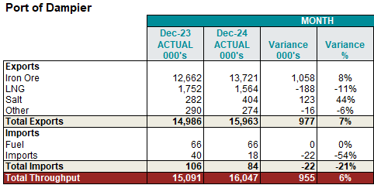
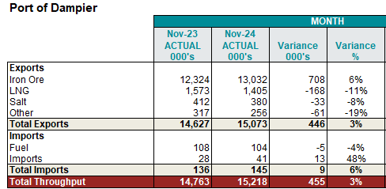
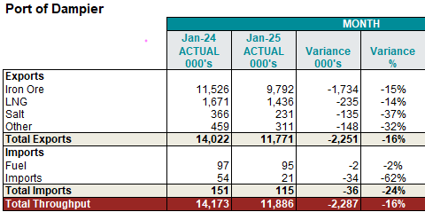

Port Closures
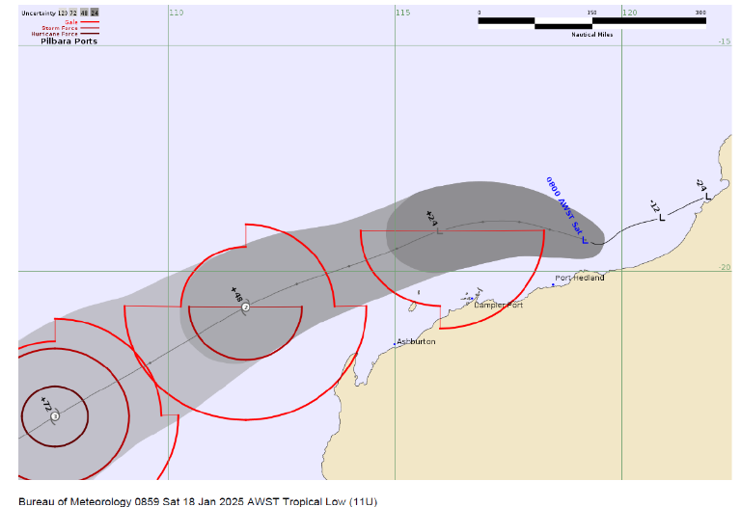
TC Sean – Clearing Port started on 18 Jan terminals reopening on the 20 and 21 Jan 2025
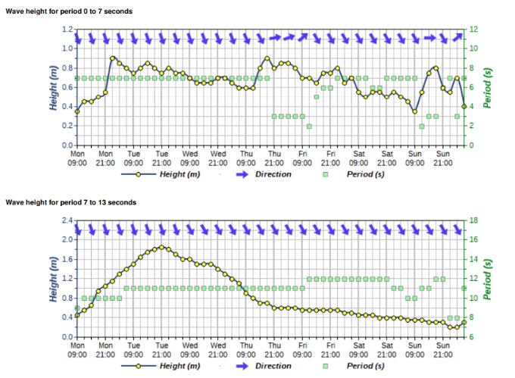
TC Taliah – 2 Feb several terminals closed due to long period swell from this tropical system.
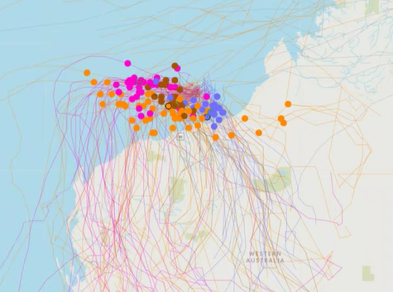
TC Zelia – 14th Feb 2025 Cyclone. Cleared Port from 13 Feb to 14 Feb
There was a question about if Pilbara Ports factors in down time each year, Pilbara Ports advised that the terminals have plans in place to mitigate risk.
There was a question that was asked on where the ships go during a cyclone, Pilbara Ports advised that ships would travel to the southern semi-circle on the North of the danger triangle, from Port Hedland to Exmouth.
ITEM 3 ENVIRONMENT UPDATE
Environment and Heritage Advisor Dane King

Cultural Heritage Management Plan (CHMP)
In mid-November 2024, Pilbara Ports invited a range of external stakeholders to review the consultation draft of the CHMP, including Traditional Owner groups (5), local/state/ commonwealth government agencies (6), and industry (5).
Positive feedback was received from a range of stakeholders during the consultation period. Some detailed and insightful comments were received and incorporated into the Plan.
The final CHMAP is now available on the Pilbara Ports website.

Dredge Plume Validation Program
The Dampier Cargo Wharf Extension and Landside
(DCWELR) was referred to the Western Australia Environmental Protection Authority in April 2022, and by June 2023, the EPA determined a formal assessment was unnecessary. As part of the Project’s Dredge Environmental Management Plan, Pilbara Ports committed to a Dredge Plume Validation Program to enhance predictive modelling and future dredging management.

Key monitoring areas:
a) Dredging Footprint – Water quality and coral monitoring along transects downstream of dredging.
b) East Lewis Island Spoil Ground – Water quality monitoring within the far-field sediment plume.

The program aims to improve future dredging predictions and management within the Port. This will support Environmental Impact Assessments (EIA) specific to the Pilbara coastline.

Mangrove Mates – 2024
Pilbara Ports Environment and Heritage Team facilitated the 2024 Mangrove Mates program to 277 students across six schools throughout the Pilbara.
The program was well received by all schools who participated.
We continue to educate the importance of mangrove communities in the Pilbara region and how the Ports interacts with these communities.

There was a question about if we offer Mangrove Mates each year. Pilbara Ports advised yes, Mangrove Mates is offered each year.

ITEM 4 TERMINAL OPERATIONS
Port Manager Dampier Georgie Arthur
Shipping and Cargo Information
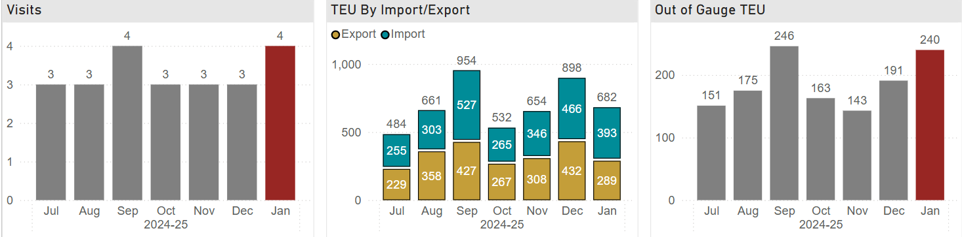

The Port continues to see an increase in trade across the Dampier Cargo Wharf. In January, the last of the modules for the Woodside Pluto 2 Project were safely delivered by specialist cargo vessel the Dongbang 6.
Planning is now underway for the Pluto 1 and the Port will take delivery of the first five (5) modules for the Perdaman Urea Project in the first week of March.

In February the Dampier Cargo Wharf hosted;
- 10 x Cargo vessels
- 13 x Offshore Vessels
- 5 x Bulk Liquid Vessels
- 3 x miscellaneous supply vessels

There was a question asked about how Terminal Operations prioritises tasks. Pilbara Ports advised that the team looks at all tasks. The main priority being keeping the port moving and operating. The supply chain and productivity are also considered when prioritising.

ITEM 5 COMMUNITY
Community Relations Lead Ariana St-Pierre
Small Grants Geo-Distribution Round 1-2-3
c
Funding prioritised towards:
- Legacy impact, such as the purchase of infrastructure or equipment
- Support of First Nations community
- Social inclusion
- Mental health resilience

Reasons applications were not supported
- Travel to Perth
- Consumables (no legacy impact, maximum $2000)
- Retrospective applications

Sponsorships
Port Hedland Chamber of Commerce and Industry (PHCCI) $1,500
PHCCI Business Excellence Awards (BEA) $6,000
PHCCI Hedland Economic Forum $1,500
Karatha Districts Chamber of Commerce Industry $7,500
(Based on previous years, awaiting prospectus)
Pilbara Summit 2025 $25,000
Onslow Chamber of Commerce and Industry (OCCI) Under assessment
OCCI BEA Awaiting prospectus
Australian Maritime Pilot Institute Awaiting prospectus
Total: $41,500

Partnerships
Marine Rescue Port Hedland (MRPH)
Replacement of a 100-year-old dilapidated building.
Pilbara Ports paid 2nd and final instalment of $100,000 to bring a total commitment to $200,000.
New office construction (under tender)

Murujuga Aboriginal Corporation (MAC) - construction of the new ranger training facility shed.
Formal acknowledgement of ongoing collaborations:
- Accumulation of sea time for rangers whilst completing mooring inspections
- Mangrove rehabilitation and seed supply
- $200,000 over two annual instalments

Local Government Authorities
Shire of Ashburton 2-year agreement ($240,000)
- Activation of space through placemaking projects
- Markets, arts events, community gardens, beautification
City of Karratha 1-year agreement ($100,000)
- Awards sponsorships (Arts, Sports, Youth)
- City Footpath Solar Lighting program

Town of Port Hedland 1-year agreement ($75,000)
- Youth adventure park infrastructure
- Ship to Shore and Good Night's concert series events
- Seniors and Youth programs
- Awards sponsorship (Citizen and Sports)

Port tours
The highest purpose for tours was careers, with community relations and industry advocacy falling behind it.

There was a question asked about if Pilbara Ports can facilitate tours in Dampier. Pilbara Ports advised that this is subject to staff availability, currently both members of the Community Relations team are based in Hedland.

There was a question asked about plans to grow the Community Relations team. Pilbara Ports advised that there are potential plans to grow the team provided they found a candidate with the correct skillset.

ITEM 6 DAMPIER CARGO WHARF EXTENSION AND LAND RECLAMATION PROJECT (DCWELR)
Project Director Dampier Cargo Wharf Projects Lizeth de la Hoz

Dampier Bulk Handling Facility (DBHF) overview
DBHF is Stage 1 of the Dampier Cargo Wharf Projects, encouraging trade diversification by opening access to a world-wide urea market.
The project team is focused on maintaining port operations while delivering the various components of the new DBHF.
These include:
- Decommissioning the existing heavy load out (HLO) and alternate load-out facility (ALF) to make way for the new wharf structure.
- Dredging, drilling and blasting to create a new berth pocket and vessel manoeuvring area.
- Installing the Mof Rd culvert to create a passageway for Perdaman’s urea conveyor.

Decommissioning of the HLO and ALF
Next steps - construction
- Construction of the new DBHF wharf will commence with piling works in late March.
- Piling will be completed via a unique internal drilling process.
- Each pile will drill the hole as it drives into the rock.
- Jack up barge will arrive onsite in mid-March to commence testing.
Stages 2 and 3 of the DCWP
- The Dampier Link Bridge and Dampier Cargo Wharf refurbishment are Stages 2 and 3 of the Dampier Crago Wharf Projects.
- Pilbara Ports will be tendering these together in mid-2025 to achieve project delivery and pricing efficiencies.

A question was asked about the DCWP aiming to double cargo. Pilbara Ports advised that the expectation is to double.

A question was asked about the size of the piles, Pilbara Ports advised that they could be up to 2 metres.

ITEM 9 ANY OTHER BUSINESS
Nil

Acting Chair thanked all those in attendance and closed the meeting at 17:00

