- SECTION 1: Meeting Information
Meeting No: 28
Meeting: | Port of Port Hedland Community Consultation Committee (PHCCC)
Location: | Pilbara Ports, L5 Kariyarra Room
Date: | 11 March 2025 |  |  | Time Open: | 15:00 |  | Time Close: | 16:15
- SECTION 2: Participants Details
Name |  | Organisation |  |  |  | Initials
Ariana St-Pierre (A/Chair) |  | Pilbara Ports |  |  |  | AS
Behrouz Daeizadeh |  | Pilbara Ports |  |  |  | BD
Lucy Georgiou |  | Pilbara Ports |  |  |  | LG
Nick Perceval |  | Pilbara Ports |  |  |  | NP
Karen Gray |  | Pilbara Ports |  |  |  | KG
John Freimanis |  | Pilbara Ports |  |  |  | JF
Chris Vale |  | Pilbara Ports |  |  |  | CV
Arnold Austin Carter |  | Community Member |  |  |  | AC
Joel Schreiber |  | Community Member |  |  |  | JS
Gloria Jacob |  | Community Member |  |  |  | GJ
Byron Everett Klein |  | Community Member |  |  |  | BE
Gary Silcock |  | Community Member |  |  |  | GS
Roger Higgins |  | Community Member |  |  |  | RH
Kelly Howlett |  | Community Member |  |  |  | KH
Lorrain Butson |  | Community Member |  |  |  | LB
Ambika Rebello |  | Community Member |  |  |  | AR

Minutes of the meeting held at the Hedland Tower
Tuesday, 11 March 2025

ITEM 1 WELCOME AND INTRODUCTION OF MEMBER

The acting chair welcomed all present and declared the meeting open at 16:15. The acting chair then commenced the meeting with an introduction of all members in attendance.

ITEM 1.1 RECORD OF ATTENDANCE/APOLOGIES

Attendance
Community Relations Lead (Acting Chair) Ariana St-Pierre (AS)
Harbour Master Port Hedland Behrouz Daei Zadeh (BD)
Executive General Manager Terminal Operations Nick Perceval (NP)
Manager Hedland Maritime Initiative Chris Vale (CV)
Environment and Heritage Superintendent Advisor Lucy Georgiou (LG)
Senior Project Manager Karen Gray (KG)
Project Director (Lumsden) John Freimanis (JF)
Head of Corporate Affairs Clare Lugar (CL)
Community Member Byron Klein (BK)
Community Member Arnold Carter (AC)
Community Member Gary Silcock (GS)
Town of Port Hedland Councillor Ambika Rebello (AR)
Community Member Joel Schreiber (JS)
Port Hedland Chamber of Commerce and Industry Scott Ballem (SB)
Community Member Kelly Howlett (NW)

Apologies
General Manager Marine (Chair) Philip Christy (PC)
Town of Port Hedland Councillor Lorraine Butson (LB)
Senior Environment Advisor Zoe Keller (ZK)
Port Manager Port Hedland East Veronica Keelan (VK)
Community Member Roger Higgins (RH)
Community Member Gloria Jacob (GJ)

ITEM 2 ACTION ITEMS

Alert System Review - Pilbara Ports to discuss community feedback with the Town of Port Hedland and Department of Fire and Emergency Services (DFES)
Lumsden Point General Arrangement: Pilbara Ports advised that there is a general arrangement that can be shared with the committee.

ITEM 3 MARINE OPERATIONS UPDATE
Harbour Master Port Hedland Behrouz Daei Zadeh
Port Statistics:
- October 2024: 47.516 million tonnes, no change from 2023.
- November 2024: 49.286 million tonnes, an increase of 8% from 2023.
- December 2024: 48.259 million tonnes, a decrease of 4% from 2023.
- January 2025: 46.525 million tonnes, an increase of 8% from 2024.
- February 2025: 37.470 million tonnes, a decrease of 5% from 2024.

Marine incidents at Port Hedland: 1 October 2024 – 28 February 2025
Total marine events: 81
While these have been classified as incidents, these are marine events which have each been successfully handled in line with our emergency response procedures and marine team.
Cyclone Alert System Changes:
- Discussion on the new alert system and its first use.
- Ambiguity in handling the new system and community perspective.
- Pilbara Ports role in messaging related to port operations, not community actions.

There was a comment made about how a lot of the community follow the guide of Pilbara Ports during cyclones. Pilbara Ports advised that although we do appreciate that, the responsibility sits with DFES. The messages sent out from Pilbara Ports during extreme weather are directly related to shipping and port operations.
There was a question asking if Channel marker 28 was blown over during cyclone Zelia. Pilbara Ports advised that there was no issue with Channel marker 28 during the cyclone.

ITEM 4 TERMINAL OPERATIONS UPDATE
Executive Manager Terminal Operations Nick Perceval
Utah: November to February
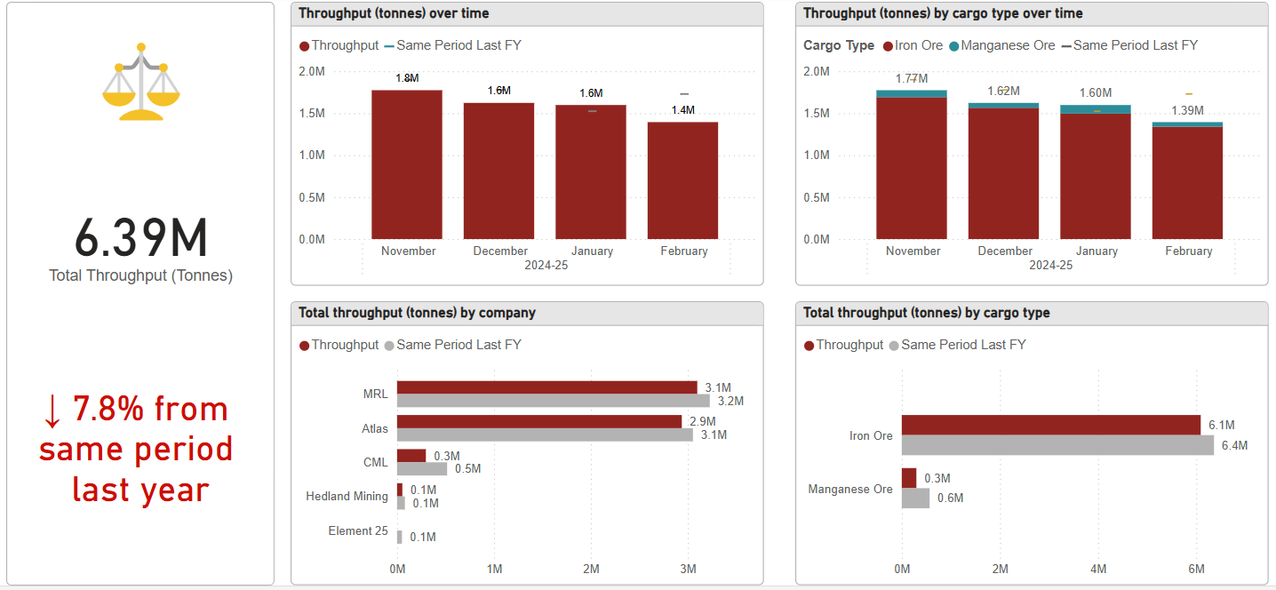
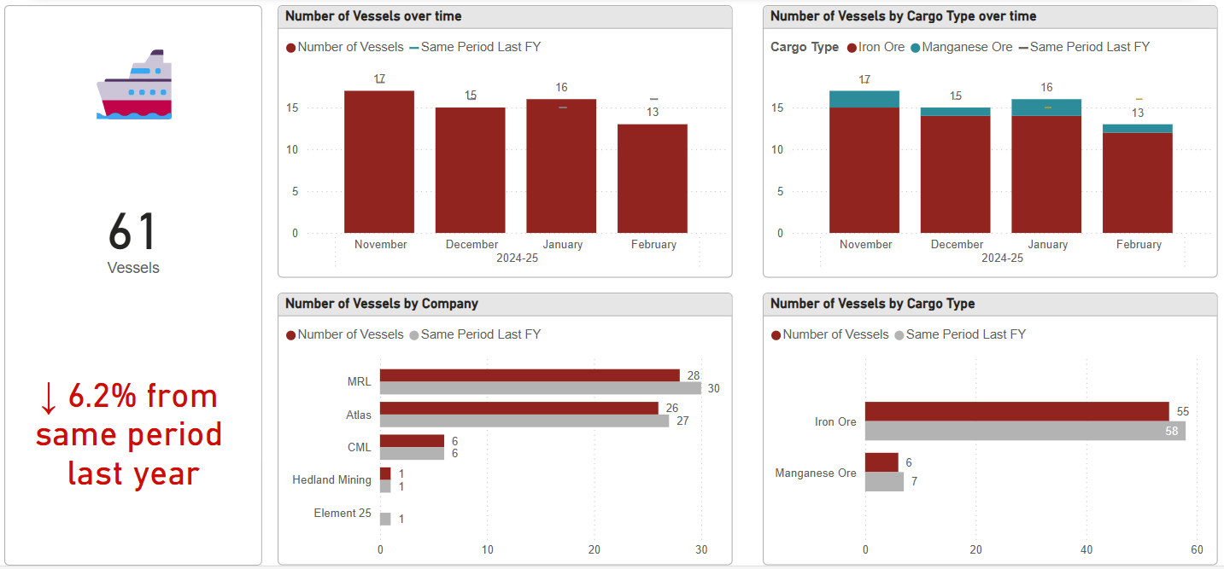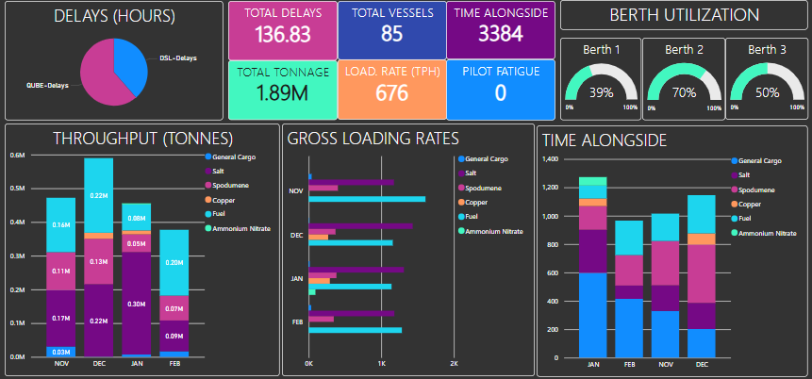
Cyclone Impact and Operations:
- Challenges faced at Utah Point due to cyclones.
- Issues with water management and facility damage.
- Impact on vessel throughput and operations

Eastern Harbour
- Installation of roller barrier system to reduce impact of frequent truck incidents damage to railing
- Converts shock energy into rotational energy and redirects vehicles back onto the road.
- Prevents trucks getting ‘hung-up’

Workforce development
- Six new apprentices started in 2025, including two females.

There was a question asked about the roller barrier system and what happens if a roller gets damaged. Pilbara Ports advised that they are easily replaceable.

ITEM 5 ENVIRONMENT AND HERITAGE UPDATE
Environment and Heritage Superintendent (Port Hedland) Lucy Georgiou

Marine Environment Quality Monitoring Program (FY24 annual report)
- Phase II – building on the data we collated during the past few years (Baseline data)
- Results were very positive. Marine and sediment quality results (heavy metals and other contaminants) were within acceptable ranges
- Aesthetically, we had no ‘red flags’ (odour, marine life).

ITEM 6 COMMUNITY UPDATE
Community Relations Lead Ariana St-Pierre
- Overview of the new Small Grants Program.
- Details on sponsorships and partnerships with local organisations.
- In-kind support and community engagement activities.

Pilbara Ports recognises the importance of establishing and maintaining strong and effective working relationships with the communities in which we operate.
To guide our efforts, Pilbara Ports established the Small Grants Program.
It allows Pilbara Ports to contribute financial and in-kind resources to community initiatives.
Applications can be submitted before those four dates:
- 19 August 2024
- 18 November 2024
- 17 February 2025
- 19 May 2025
To view the guidelines or to find the application form, visit: https://www.pilbaraports.com.au/community/small-grants
Approved in Round 2:
- St John Ambulance – Ice Machine $3,950
- Safe Hedland – Cat Litter and Puppy Pads $2,000
- North Pilbara Football League – Match Balls $15,673
- Onslow Marine Rescue Marquee and Tablecloths $2,500
- Karratha Water Polo Association– Inflatable water Polo Field $4,000
- Karratha Fire and Rescue– Volunteer Bus $14,700
- Bunnaliyarra Red Arts Arts Festival – Juluwara Art Group $8,000
- headspace Karratha- Garden in the Green $4,171
- Dampier Tennis Club– Reverse Osmosis System $4,300 Total: $59,335
Or email smallgrants@pilbaraports.com.au for more information.
Funding prioritised towards:
- Legacy impact, such as the purchase of infrastructure or equipment
- Support of First Nations community
- Social inclusion
- Mental health resilience
Reasons applications were not supported
- Travel to Perth
- Consumables (no legacy impact, maximum $2000)
- Retrospective applications

Geo breakdown of Applications from Grants in Rounds 1 to 3

Sponsorships
Port Hedland Chamber of Commerce and Industry (PHCCI) $1,500
PHCCI Business Excellence Awards (BEA) $6,000
PHCCI Hedland Economic Forum $1,500
Karatha Districts Chamber of Commerce Industry $7,500
(Based on previous years, awaiting prospectus)
Pilbara Summit 2025 $25,000
Onslow Chamber of Commerce and Industry (OCCI) Under assessment
OCCI BEA Awaiting prospectus
Australian Maritime Pilot Institute Awaiting prospectus
Total: $41,500

Partnerships
Marine Rescue Port Hedland (MRPH)
- Replacement of a 100-year-old dilapidated building.
- Pilbara Ports paid 2nd and final instalment of $100,000 to bring a total commitment to $200,000.

Murujuga Aboriginal Corporation (MAC)
- Construction of the new ranger training facility shed.
- Formal acknowledgement of ongoing collaborations:
  - Accumulation of sea time for rangers whilst completing mooring inspections
  - Mangrove rehabilitation and seed supply
- Builds on existing commitments from MAC and funding from:
  - 2-year commitment from Pilbara Ports
  - $200,000 over two annual instalments

Local Government Authorities
Shire of Ashburton 2-year agreement ($240,000)
- Activation of space through placemaking projects
- Markets, arts events, community gardens, beautification

City of Karratha 1-year agreement ($100,000)
- Awards sponsorships (Arts, Sports, Youth)
- City Footpath Solar Lighting program

Town of Port Hedland 1-year agreement ($75,000)
- Youth adventure park infrastructure
- Ship to Shore and Good Night's concert series events
- Seniors and Youth programs
- Award sponsorships (Citizen and Sports)

Tours

There was a question asked about if there was an age limit for the tours. Pilbara Ports advised that now there is no age limit. Pilbara Ports has partnered up with Odyssey which has bought chid size life jackets to be able to cater to primary schools.
There was a question about the Pilbara Summit and who can attend that event. Pilbara Ports advised that it is hosted in Karratha but is open to the entire Pilbara region.
There was a question asked if Pilbara Ports could speak to the mangrove and ranger programs. Pilbara Ports advised that there is a mangrove nursery on sight where they collect mangrove seeds and rehabilitate areas that have been affected by cyclones. The ranger program is the entity that helps find areas for mangrove rehabilitation as well as provides guidance and further insights on this. The ranger program also visits schools for education purposes.
There was a question asked if there was a partnership with any indigenous groups here in Port Hedland. Pilbara Ports advised that they are currently working on a few different project opportunities in Port Hedland and Roebourne alongside the First Nations Engagement team. Pilbara Ports has had a partnership with the Clontarf Foundation for a few years and is looking at revamping this partnership in 2026, as well as expanding to the female equivalent program.
There was a question asked about the length of these partnerships. Pilbara Ports advised that these partnerships are all under two years other than The Shire of Ashburton. Pilbara Ports is looking at establishing longer partnerships in the future.
ITEM 7 PROJECTS / SPECIAL ISSUES
ITEM 7.1 LUMSDEN POINT
Project Director (Lumsden) John Freimanis
Road and Intersection upgrades
- Creating a roundabout, bridges and access ramps to improve road safety and accommodate increasing traffic volumes and oversized vehicles coming in and out of Lumsden Point. Completion is expected in 2025.

Wharfs Upgrades
- Two new wharfs, known as PH5 and PH6, will facilitate the export of critical battery metals and enable the import of renewable energy infrastructure.

There was a question asked about the weight of the two new harbour cranes, Pilbara Ports advised that they were 200 tonnes.

There was a question raised about if there are any up-to-date plans available for viewing regarding the wharf upgrades. Pilbara Ports advised that there is a general arrangement that can be shared with the committee.

There was a question asked about when the two wharfs will be completed. Pilbara Ports advised that the aim of completion is the second half of 2026, but construction will still be running for a short while after that.
ITEM 7.2 HEDLAND MARITIME INITIATIVE
Manager – Hedland Maritime Initiative (HMI) Chris Vale
As of 28 February 2025: Progress on residential and non-residential property acquisitions.
Of the estimated 404 eligible residential properties:
- 69% have been sold or are selling to HMI, including:
  - 6 properties are progressing to settlement.
  - 5 properties are at contract stage.
  - 268 properties have been acquired.
  - 87% have been or are being valued.
  - 349 offer letters have been issued.
Of the estimated 22 eligible non-residential properties:
- 68% have been sold or are selling to HMI, including
  - 9 properties are progressing to settlement
  - 0 properties are at contract stage
  - 6 properties have been acquired
  - 86% have been valued
  - 19 offer letters have been issued

Current projects
- Short-stay accommodation pool. Occupancy rate of 61 % (small business 14.3%, Community and not-for-profits 21.4%, larger business/mining and port 64.3% of bookings)
- Hedland First National are property managing short-stay rentals
- Recent cyclone event – Remote communities have reached out for assistance with accommodation to assist key workers with accommodation.
- Care for Hedland also utilising properties to accommodate Turtle monitors throughout nesting season

There was a question asked about the ratio of demolition. HMI advised that at this stage, 10 properties have been demolished due to safety reasons and asbestos.
There was a question asked about using these properties as potential walk-in precincts for tourism, HMI advised that there is a steering committee which has formed where these suggestions are fed back to Parliament. HMI always welcomes community support and ideas.
There was a question asked about if there is a qualifying criterion for community members using the short-stay accommodation. HMI advised that they have a discount structure.
There was a question asked about where most customers come from for the short-stay accommodation. HMI advised that there is a wide variety that come forward including private, mining companies, executives and more recently due to the cyclone, rural communities who have been displaced.
There was a question asked on the percentage of not for profits and community organisations that make up the bookings for short stay accommodation, HMI advised that it is currently 21.4%.
ITEM 7.3 SEAFARERS CENTRE UPDATE
Senior Project Manager Karen Gray
- Tender process and design updates for the new Seafarers Centre.
- Removed accommodation from the design due to cost factors.
- Integration with the port's car park upgrade project.

There was a question asked about any plans of demolishing the old house near the new Seafarer’s Centre. Pilbara Ports advised that the information they were given recently is that that house will be demolished and there will be permission given to use it for laydown during construction and later to be used for parking purposes.
ITEM 10 Discussion and Question / Other Business
Care for Hedland
- Update from Care for Hedland on turtle nesting season and volunteer efforts.
- Discussion on the impact of hot weather on hatchling success.
- Upcoming Sustainable Living Show Day event.

