This worksheet forms part of the Hazard Identification and Risk Management process as outlined in Hazard Management Procedure and Risk Management Procedure.

Isolation Required: |  | Yes | ☐ | No | ☐ | If Yes- Isolation No. |  |  |  |  |  |  |  |  |  |  |  | Work order no.
Permits Required: | High Voltage Access |  |  |  |  |  | ☐ |  | Confined Space |  |  | ☐ |  | Working at Heights |  |  |  |  | ☐ |  | Abrasive Blasting |  |  |  | ☐ |  |  | Excavation |  | ☐
 | Hot Work |  |  |  |  |  | ☐ |  | Tank Diving |  |  | ☐ |  | Diving |  |  |  |  | ☐
Company Name: |  |  |  |  |  |  |  |  |  |  |  |  | Task supervisor: |  |  |  |  |  |  |  |  |  |  | Contact no:
Duration of task (max 7 consecutive shifts): |  |  |  |  |  |  |  | Valid from: |  | DATE |  |  |  |  |  | TIME |  |  |  | Valid until: |  | DATE |  |  |  |  |  |  | TIME
Work location:
Activity:

By signing onto this Job Hazard Analysis Worksheet, all persons involved in the job/activity confirm that they:
- have been involved in the development of this JHA, including planning the job steps and analysing each hazard; or have reviewed and given input to the contents prior to joining the work group;
- understand the work, scope and methods for the task and have communicated the requirements of this JHA with any other workers that may be affected by the task; and
- agree to stop the task, review, reassess and gain approval prior to recommencement (due to change in task, conditions or if a new hazard identified).
Name | Sign | Date |  | Name | Sign | Date |  | Name | Sign | Date
Name | Sign | Date |  | Name | Sign | Date |  | Name | Sign | Date
Name | Sign | Date |  | Name | Sign | Date |  | Sign-on Extension over page

Pilbara Ports Review - By signing onto this Job Hazard Analysis Worksheet, I (the Task Supervisor) confirm that I have:
☐ | reviewed the JHA and informed workers of permit requirements;
☐ | verified that all job steps have been recorded and hazards identified;
☐ | verified workers have the required qualifications, training and licences; and
☐ | deemed the stated controls to be effective to reduce the risk to the relevant rating (Low, Moderate or High) and critical controls are included for critical risks.
The JHA must be reviewed according to the highest risk before the task may commence. For risks to the categories of “life/health” or “environment/heritage”, controls must be implemented to As Low As Reasonably Practicable (ALARP).
Task Supervisor Name |  | Signature |  | Contact No |  | Date
Task Supervisor Name |  | Signature |  | Contact No |  | Date
Task Supervisor Name |  | Signature |  | Contact No |  | Date
Extreme – Where the residual risk is deemed Extreme, then the task must not commence.

Name | Sign | Date |  | Name | Sign | Date |  | Name | Sign | Date
Name | Sign | Date |  | Name | Sign | Date |  | Name | Sign | Date
Name | Sign | Date |  | Name | Sign | Date |  | Name | Sign | Date
Name | Sign | Date |  | Name | Sign | Date |  | Name | Sign | Date
Name | Sign | Date |  | Name | Sign | Date |  | Name | Sign | Date
Name | Sign | Date |  | Name | Sign | Date |  | Name | Sign | Date
Name | Sign | Date |  | Name | Sign | Date |  | Name | Sign | Date
Name | Sign | Date |  | Name | Sign | Date |  | Name | Sign | Date
Name | Sign | Date |  | Name | Sign | Date |  | Name | Sign | Date
Name | Sign | Date |  | Name | Sign | Date |  | Name | Sign | Date
Name | Sign | Date |  | Name | Sign | Date |  | Name | Sign | Date
Name | Sign | Date |  | Name | Sign | Date |  | Name | Sign | Date
Name | Sign | Date |  | Name | Sign | Date |  | Name | Sign | Date
Name | Sign | Date |  | Name | Sign | Date |  | Name | Sign | Date
Name | Sign | Date |  | Name | Sign | Date |  | Name | Sign | Date
Name | Sign | Date |  | Name | Sign | Date |  | Name | Sign | Date
Name | Sign | Date |  | Name | Sign | Date |  | Name | Sign | Date
Name | Sign | Date |  | Name | Sign | Date |  | Name | Sign | Date
Name | Sign | Date |  | Name | Sign | Date |  | Name | Sign | Date
Name | Sign | Date |  | Name | Sign | Date |  | Name | Sign | Date
Name | Sign | Date |  | Name | Sign | Date |  | Name | Sign | Date
Name | Sign | Date |  | Name | Sign | Date |  | Name | Sign | Date
Name | Sign | Date |  | Name | Sign | Date |  | Name | Sign | Date
Name | Sign | Date |  | Name | Sign | Date |  | Name | Sign | Date
Name | Sign | Date |  | Name | Sign | Date |  | Name | Sign | Date

Steps in the development of a JHA:
Step | Description
Review the scope of the job | Once the decision to develop a JHA for a specific job is made, a Task Supervisor can start the process by seeking input from one or more workers who are familiar with the job. Getting experienced workers involved in the process will assist in uncovering or minimising oversights of the specific hazards.
Activity | Break down the task step by step.  Identify each task of the job and break it down into individual steps - The job process needs to be broken down into individual steps from start to finish and the steps should be documented in a logical order. It is important to describe and record each step briefly.
Hazards | Identify the hazards, also use the prompts provided on the JHA Worksheet as a guide. Note that the prompts are only a guide and not an exhaustive list.
Risk Control Measures | Determine controls to mitigate the hazard using prompts provided on the JHA Worksheet as a guide. Note that the prompts are only a guide and not an exhaustive list.
Residual Risk Rating | Using the Pilbara Ports Risk Matrix, calculate the risk with the identified controls in place.
Review | The review section of the JHA is completed in accordance with Section 7.6 of the hazard management procedure.  Where the reviewer is not familiar with a task or not confident that the proposed controls will reduce the risk to the required level then they must refer the JHA up through their line manager.
Sign the JHA | All personnel involved in the task must read, understand and sign onto the completed JHA.
Communicate | Communicate with other workers in the area.
Perform the task | Complete the task ensuring all controls listed in the JHA are followed.  Where there is a change, it must be done in accordance with Section 7.3.5(c) or 7.3.5(d) of the hazard management procedure, as relevant. Where there has been an incident or ‘Stop Work Authority’, then section 7.3.4(b) and 7.3.5(e)of the hazard management procedure must be followed.
Re-sign the JHA | All personnel involved in the task must read, understand and sign onto the completed JHA every new shift for no more than seven shifts. After seven shifts, a new JHA must be completed.

Refer to Pilbara Ports Hazard Management Procedure (A309296) for more information.

Does The Job Involve Any Critical RIsks – If a Critial Risk is identified I Must understand and Implement the Critical Controls
☐ |  | Fall from height |  | ☐ Edge Protection OR |  | ☐ |  | Vehicle collision or rollover |  | ☐ Seatbelts Worn &
☐ |  |  |  | ☐ Fall Restraint System / Fall-Arrest System |  | ☐ |  |  |  | ☐ Fitness for Work &
☐ |  | Confined Spaces |  | ☐ Isolation & Lockout/tagout of Energy Sources (if present) & |  | ☐ |  |  |  | ☐ Distraction Free Driving
☐ |  |  |  | ☐ Atmospheric Testing & Monitoring |  | ☐ |  | Uncontrolled release of tension - mooring lines and cables |  | ☐ Mooring Line / Cable Integrity Management Program &
☐ |  | Electrical energy exposure |  | ☐ Positive Electrical Isolation & lockout/tagout (LV & HV) & |  | ☐ |  |  |  | ☐ Certified Mooring Equipment & Fittings &
☐ |  |  |  | ☐ Earthing & Test-for-De-Energised |  | ☐ |  |  |  | ☐ Snap-Back / Exclusion Zone Identification & Delineation
☐ | 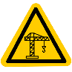 | Lifting Operations |  | ☐ Verified Load Weight & Rigging Capacity Check & |  | ☐ |  | Dropped Objects |  | ☐ Barricaded Exclusion Zones &
☐ |  |  |  | ☐ Certification of Rigging Gear & |  | ☐ |  |  |  | ☐ Tool & Equipment Tethering &
☐ |  |  |  | ☐ Dedicated Exclusion Zone |  | ☐ |  |  |  | ☐ Work Platform Edge Protection
☐ |  | Working in, on, or near water |  | ☐ Edge Protection / Physical Barriers (guard-rails, barricades) OR |  | ☐ |  | Entanglement & crushing |  | ☐ Fixed Guarding of Hazardous Parts &/OR
☐ |  |  |  | ☐ Fall-Restraint System at Water’s Edge OR |  | ☐ |  |  |  | ☐ Interlocked Movable Guards &/OR
☐ |  |  |  | ☐ Personal Flotation Device |  | ☐ |  |  |  | ☐ Presence-Sensing Safety Devices &/OR
☐ |  | Mobile equipment interaction |  | ☐ Heavy mobile plant segregation (barriers, kerbs, and/or walkways) |  | ☐ |  |  |  | ☐ Energy Isolation & lockout/tagout
Task Specific PPE Required for the Job
☐ Respiratory protection |  |  | ☐ Head protection |  | ☐ Foot protection |  |  |  | ☐ Eye protection |  | ☐ Personal flotation device
☐ Hearing protection |  |  | ☐ UV protection |  | ☐ Hand protection |  |  |  | ☐ Protective clothing |  | ☐ Face protection

Examples of some typical potential Health, Safety and Environmental Hazards you may encounter on your job
☐ Spill of Hazardous Materials | ☐ Rotating Plant / Equipment | ☐ Hydraulic | ☐ Lighting | ☐ Hazardous Substances | ☐ Psychosocial
☐ Spill of Contaminated Soil | ☐ Mobile Plant | ☐ Hot Work | ☐ Gas | ☐ Uneven Surfaces | ☐ Excavations
☐ Waste Generation | ☐ Line of Fire / Suspended Loads | ☐ Pressure | ☐ Biological | ☐ Hot Surfaces | ☐ Weather / Hot Temperatures
☐ Dust / Fumes | ☐ Manual Handling | ☐ Noise | ☐ Storms / Lightning | ☐ Other Workers | ☐ Diving Operations
☐ Asbestos | ☐ Pneumatic | ☐ Stored Energy | ☐ Objects in Path | ☐ High Pressure Water | ☐ Vibration
Examples of Health, Safety and Environmental Control Measures which may be utilised to enhance safety on your job
☐ Bunding | ☐ Isolations | ☐ Extraction Fans | ☐ Rescue Equipment | ☐ SDS Available | ☐ Gas Detection
☐ Spill Kits | ☐ Respiratory Protection | ☐ Ventilation Fans | ☐ Portable Lighting | ☐ Pre-Start Inspections | ☐ Signage
☐ Mechanical Lifting Equipment | ☐ Spotter/s | ☐ Barricades | ☐ Soaker Pads | ☐ Fall Protection | ☐ Permits
☐ Intrinsically Safe Equipment | ☐ Housekeeping | ☐ Scaffolding | ☐ Skip Bins | ☐ Work Breaks | ☐ Two-way Radios
☐ Fire Extinguishers / Hoses | ☐ Fire Blankets | ☐ Rescue Plan

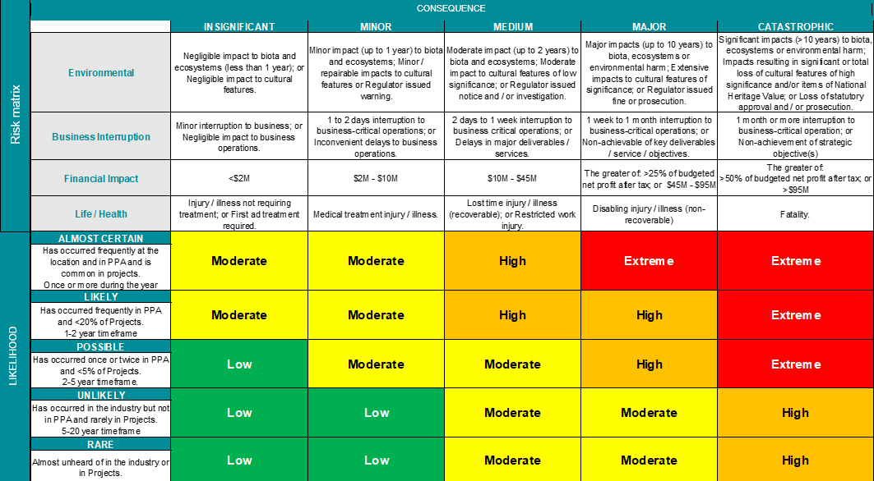

 | AUTHORITY TO ACCEPT RISK
LOW |  | Where the residual risk is Low, then the employee or work group have the authority to authorise and commence the task.
MODERATE |  | Where the residual risk is Moderate, the task-based risk assessment must be reviewed by a Task Supervisor who is employed as a Level 6 or higher. Pilbara Ports employees employed at Level 6 or higher can authorise persons under their direct control that can demonstrate knowledge and competence to authorised task-based risk assessments with a residual risk rating of Moderate on their behalf.
HIGH |  | Where the residual risk is High, the task-based risk assessment must be reviewed by a Task Supervisor who is employed as a Pilbara Ports Department Manager.
EXTREME |  | Where the residual risk is deemed Extreme, then the task must not commence.

STEP No. | ACTIVITY  Describe each of the steps in the sequence they are carried out. | HAZARDS  Identify specific hazards that could cause harm when the activity is performed. | RISK CONTROL MEASURES  List the control measures required to eliminate or minimise the risk of any negative consequence arising from the identified hazard. | RESIDUAL  RISK  RATING
EXAMPLE – SUFFICIENT DETAILS: Refer to Hazard Management Procedure for further guidance
EXAMPLE | Carry tools from car to worksite | Other workers in the area | Communicate with all work groups in the area prior to moving in with equipment.  Barricade worksite with caution tape and tag and only work inside.
EXAMPLE |  | Heavy materials | Use correct lift and carry techniques at all times. Two people to lift and carry heavy items.
EXAMPLE |  | Uneven work surfaces - Stairs and walkways | Maintain stable footing on all levels and steps.  Carry tools and equipment in tool bag and hold handrail.

STEP No. | ACTIVITY  Describe each of the steps in the sequence they are carried out. | HAZARDS  Identify specific hazards that could cause harm when the activity is performed. | RISK CONTROL MEASURES  List the control measures required to eliminate or minimise the risk of any negative consequence arising from the identified hazard. | RESIDUAL  RISK  RATING

1. process owner
The Health and Safety Manager is responsible for this Form.

